Fully Dressed UC3:

Player Gathers Resources

Architecturally Significant

# 

# Table of Contents

**Table of Contents** **1**

**Use Case** **2**

**Scope** **2**

**Level** **2**

**Primary Actor** **2**

**Stakeholders and Interests** **2**

**Preconditions** **2**

**Success Guarantee** **2**

**Main Success Scenario** **2**

**Extensions** **2**

**Special Requirements** **3**

**Technology and Data Variations List** **3**

**Frequency of Occurrence** **3**

**Miscellaneous** **3**

**System Sequence Diagram** **3**

*highlights indicate changes

# 

# Use Case:

Player Gathers Resources

# 

# Scope:

City Builder Game Application

# 

# Level:

user-goal

# 

# Primary Actor:

Player

# 

# Stakeholders and Interests:

Players- If the player is not able to gather a resource, they cannot play the game Administrator- The administrator needs to check if the users got the appropriate resources when the player goes to gather

Developers- need to make sure that the appropriate resources are assigned to the named actions visible by the players

Evaluator- We get graded on if the project works, and this helps the project work

# 

# Preconditions:

System is running, Players are logged in, Player is at the system, Player can input into the system

# 

# Success Guarantee:

Player has the resource gathered, Player is able to see all resources that they have, Player is able to spend resources on their next turn, Play is passed to the next player,

# 

# Main Success Scenario:

Administrator starts the system

Players are logged in and authenticated

Player takes the gather resource action

System gives the appropriate resource to the player

System updates the Player resource count

Player sees total resource count

Play passes to the next player

System gives control to the next player

# 

# Extensions:

* Player is not able to gather resources because their opponent already took that action
* Player wants to take back choice
  + System takes back resources it gave to player
  + System restores rolls back the choice to give the player their action back
  + Control is returned to the player

# 

# Special Requirements:

* System shows updated resources within 5 seconds of the gather action being taken
* System works in both Linux and C++
* Shows all options in English

# 

# Technology and Data Variations List:

* System Administrator Override by entering user name and password

# 

# Frequency of Occurrence:

Happens every turn of the game

# 

# Miscellaneous:

What are the resource caps on the players?

Can a player take the same action more than once?

When can a player not take back their action?

How often can they take back an action?

# System Sequence Diagram

In this use case, the player(s) first logs into the system. The system successfully authenticates the player(s) and a player starts the game. Player(s) will begin their turn and uses gatherResource(). The system will then update their total and display the updated resources to the user. In this iteration, the login is uncompleted and is very basic at this point. We plan to add cancelGather() to allow the player to cancel gathering a resource, and we also plan to add different resources since at this point we only have one resource available.

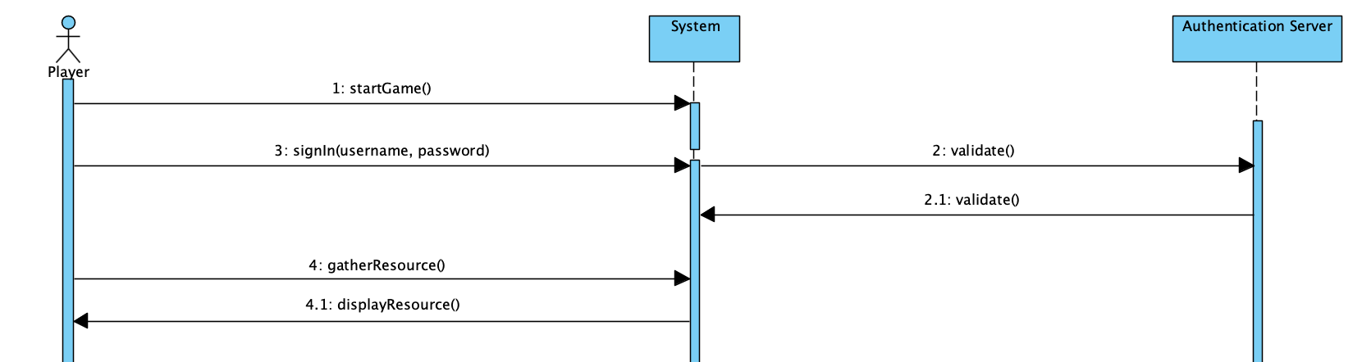

**Alternate Scenario**

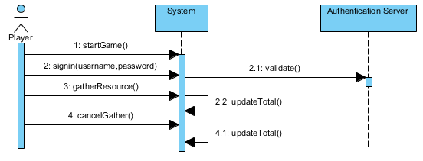

In this scenario, the player would like to undo their gather action. They have already started the game [startGame()], signed in [signin()] with validation [validate()], and gathered a resource [gatherResource()]. They have decided that they did not want to gather on their turn, so after they chose the option they would like to cancel it [cancelGather()]. The system will update the players total resources and return control to the playe

r so that they may take their turn as normal.